**PHASE 4**

**DEVELOPMENT PART 2**

|  |  |
| --- | --- |
| **DATE** | 26 OCTOBER 2023 |
| **TEAM ID** | 715 |
| **DOMAIN NAME** | DATA ANALYTICS |
| **PROJECT NAME** | PRODUCT SALES ANALYSIS |
| **MAXIMUM MARKS** |  |

**INTRODUCTION:**

The main objective of this phase is to visualize data that is used for predicting the future sales and customer preferences in product sales analysis.

**PROBLEM STATEMENT:**

Predict future sales performance for each product, region depending on top-selling products, peak sales analysis and customer preferences.

**VISUALIZATION OF DATA:**

**Calculating the average of unit sales and revenue of products:**

Q-P1: Total unit sales of Product 1

Q-P2: Total unit sales of Product 2

Q-P3: Total unit sales of Product 3

Q-P4: Total unit sales of Product 4

S-P1: Total revenue from Product 1

S-P2: Total revenue from Product 2

S-P3: Total revenue from Product 3

S-P4: Total revenue from Product 4

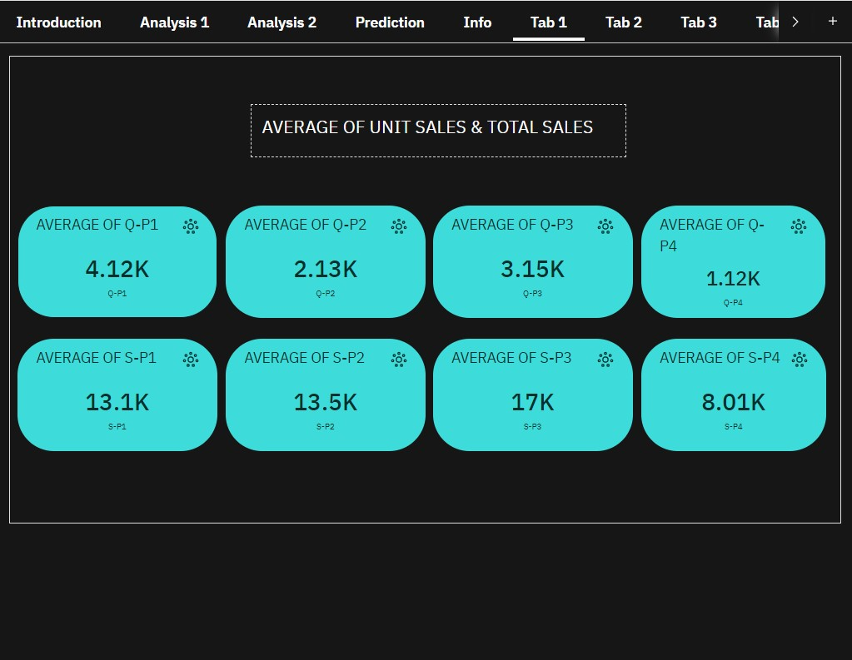

**Visualization on sum of total unit sales & total revenue of products:**

There are four products(P1, P2, P3, P4) sold by REC Corp Ltd. So it is necessary to visualize the range of products according to Unit sales and its revenue.

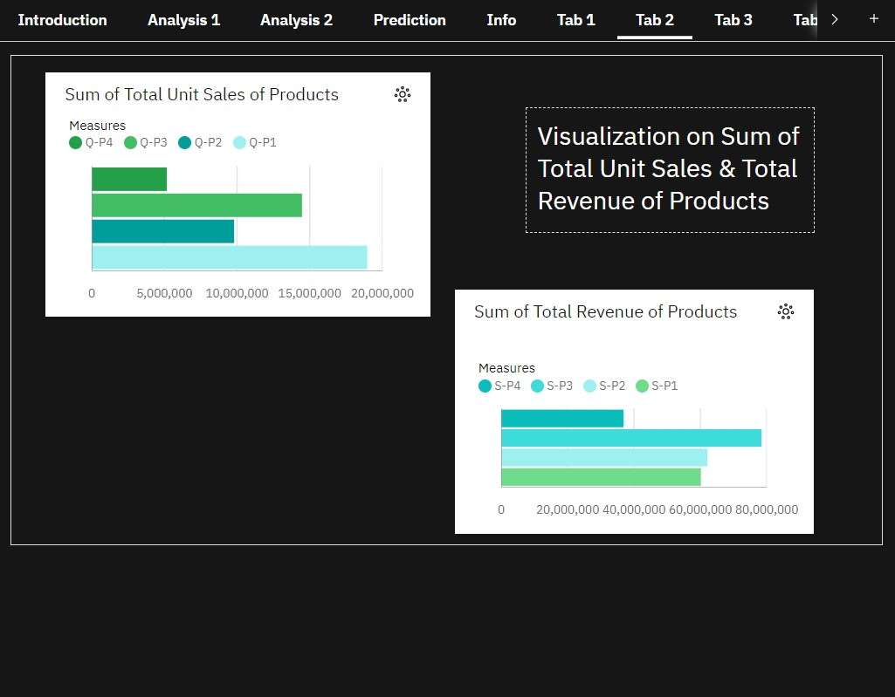

**Comparing each unit sales & its revenue:**

It is necessary to compare the total unit sales and total revenue of each product.

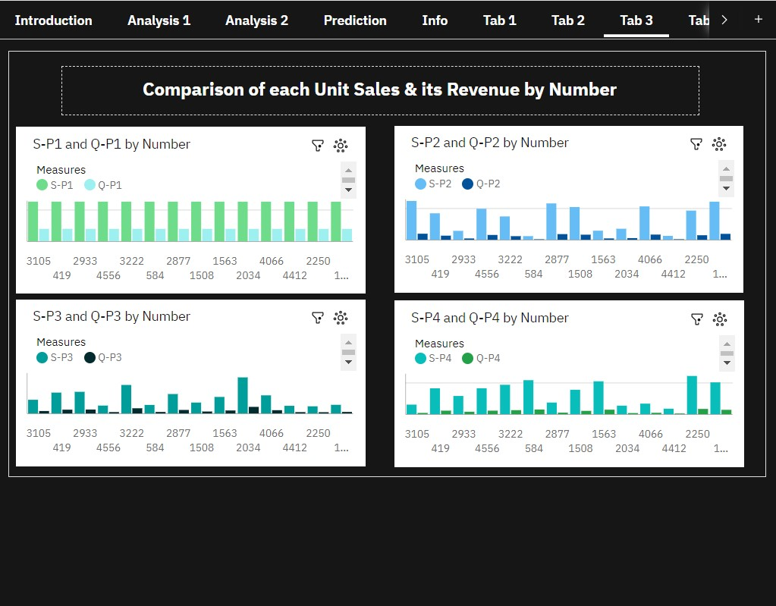

**Visualizing revenue of products over few years:**

The unit sales and its revenue changes each and every year. Visualizing revenue of products happened over years helps in predicting future sales.

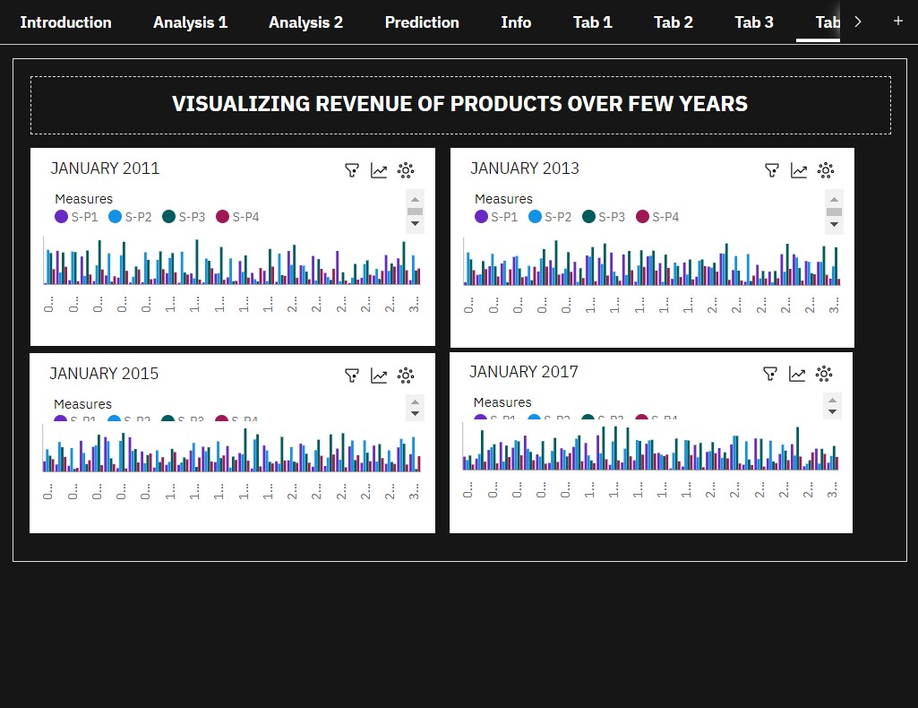

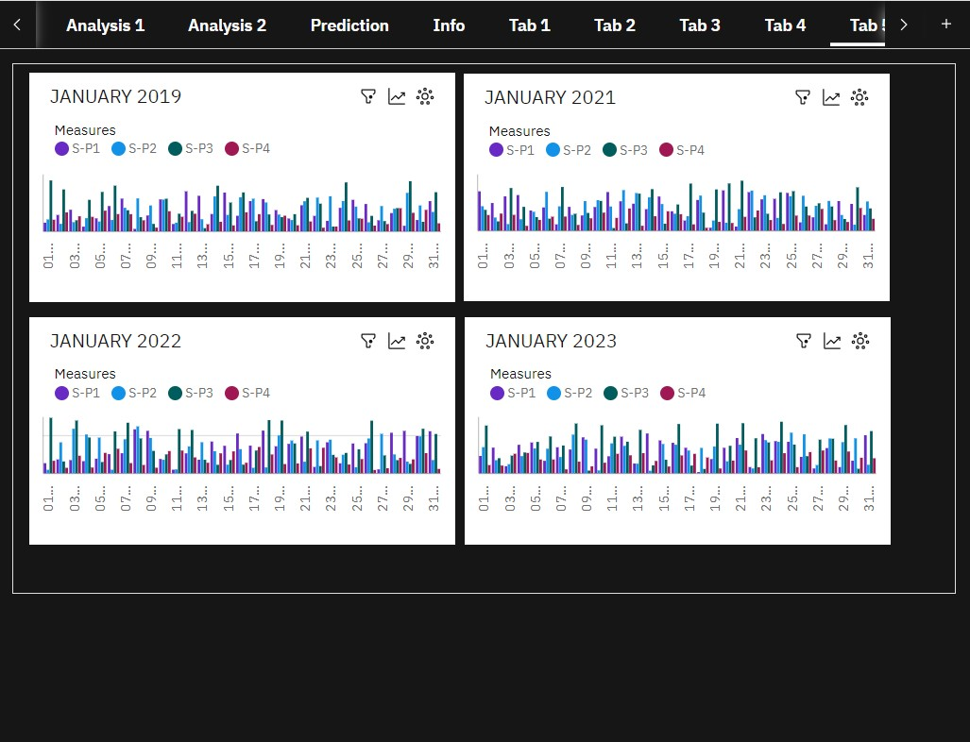

**DECADE TRAVEL:**

Since it is very difficult to analyse each data, it is good to have a drop down list that contain date and year. Using this date and year it is easy to analyse unit sales and its revenue over decades.

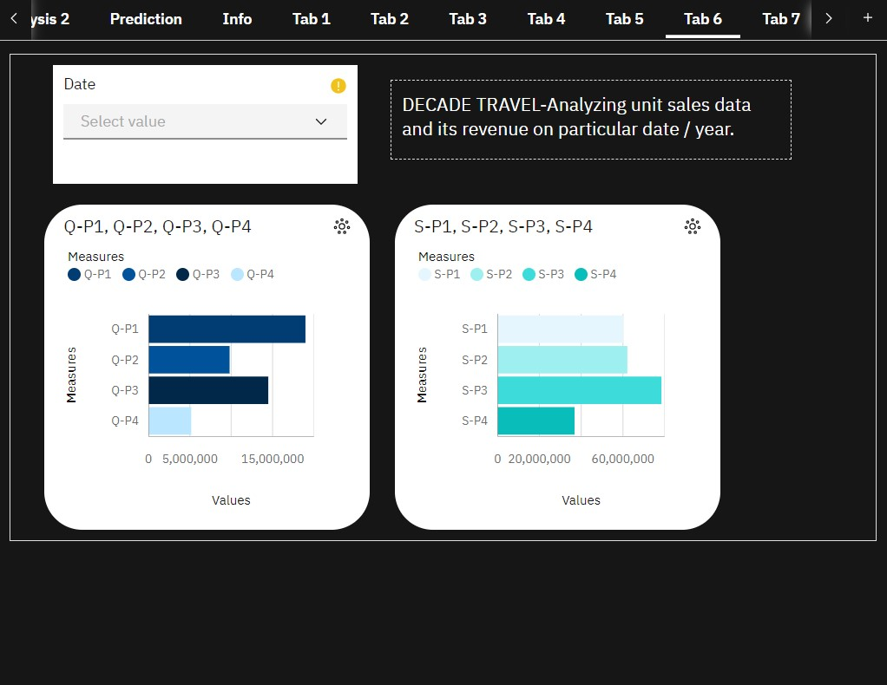

**Analysing revenue of products by unit sales using average:**

Revenue of products is analysed by using the average calculated.

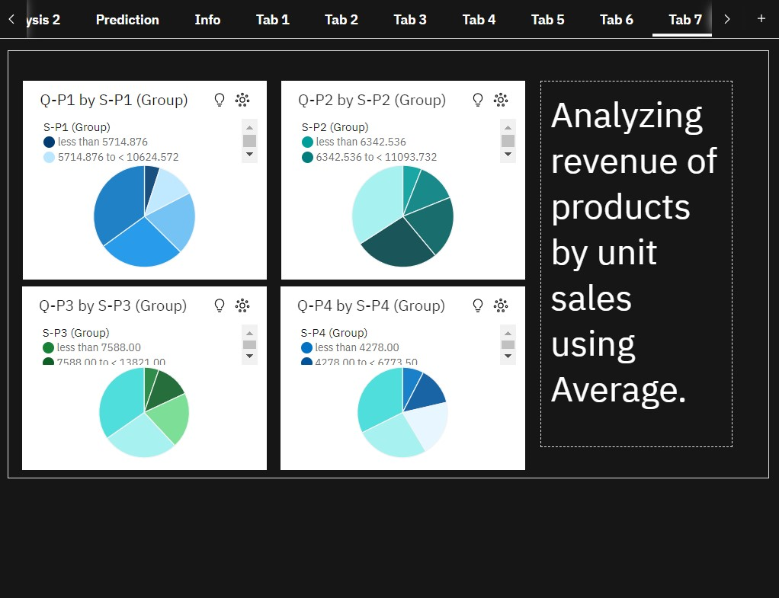

**Predicting the strength of revenue of products:**

In order the predict the sales in future, it is necessary to predict the revenue status happened over decades.

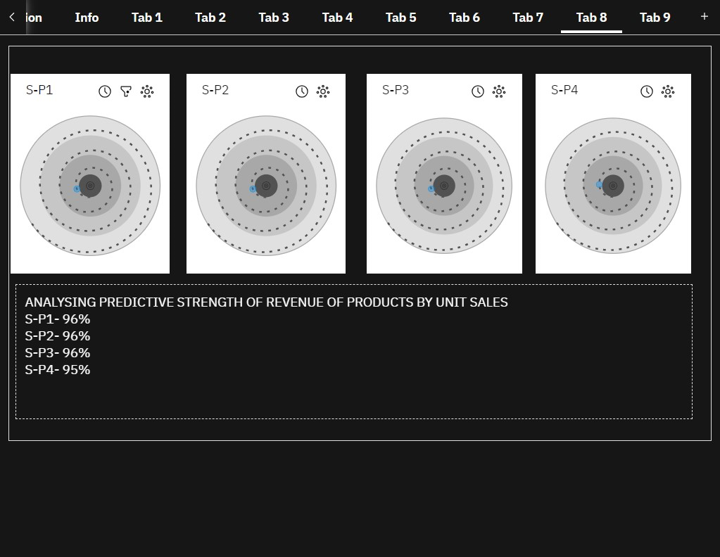

According to this analysis

Revenue of P1, P2, P3 and P4 are almost near to 100%, which means the revenue of P1, P2, P3 and P4 will be higher in future.

(i.e) Total Revenue of P1 – 96%

Total Revenue of P2 – 96%

Total Revenue of P3 – 96%

Total Revenue of P4 – 95%

**Predicting the unit sales of products**

Similarly it is necessary to predict the status of unit sales of products over decades.

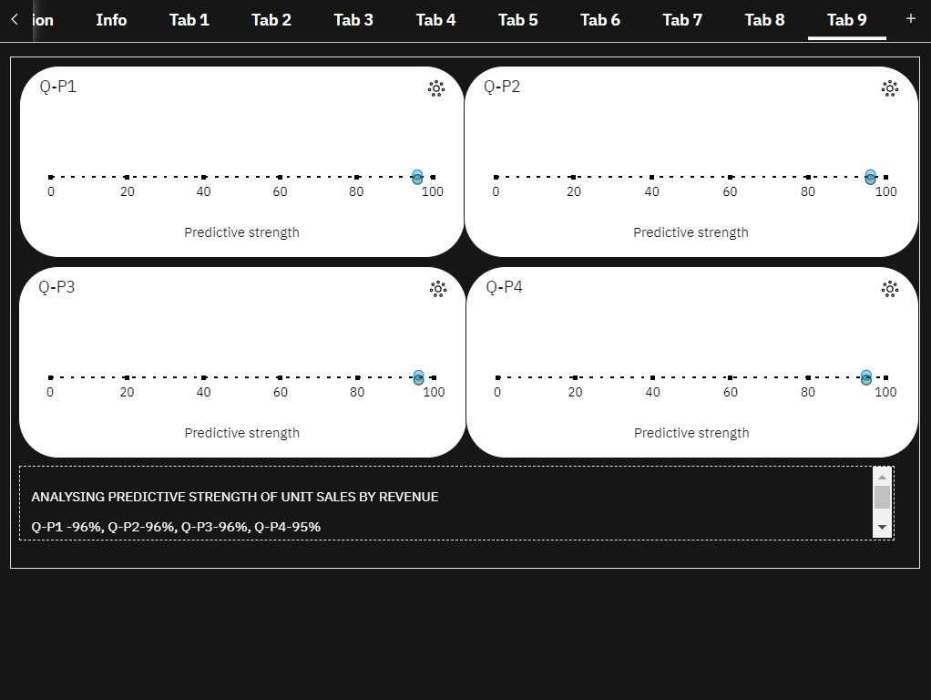

According to this analysis

Unit sales of P1, P2, P3 and P4 are almost near to 100%,

(i.e)Unit Sales of P1 – 96%

Unit Sales of P2 – 96%

Unit Sales of P3 – 96%

Unit Sales of P4 – 95%

which means the unit sales of P1, P2, P3 and P4 will be higher in future.

**FINAL DASHBOARD**

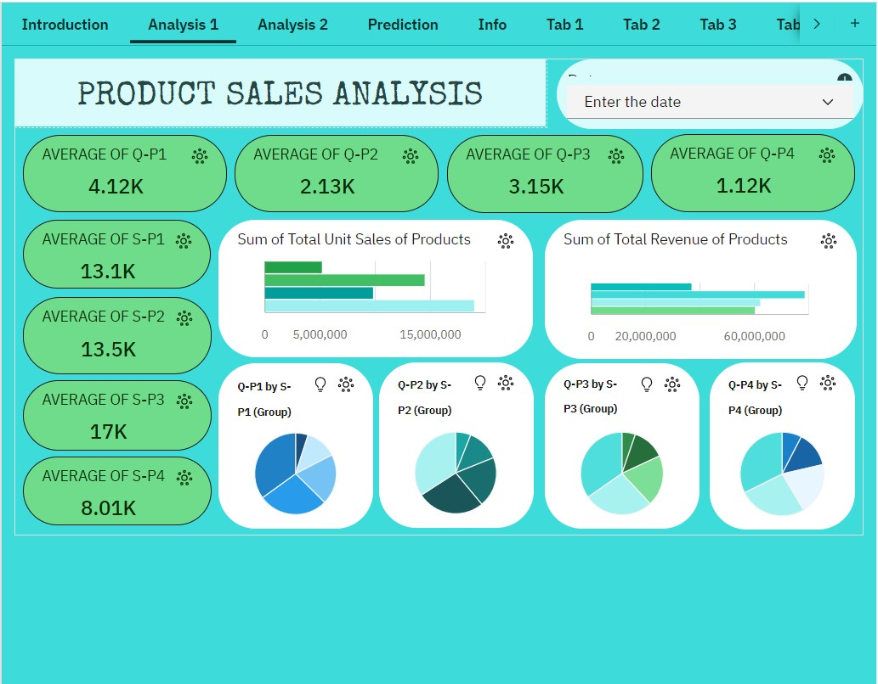

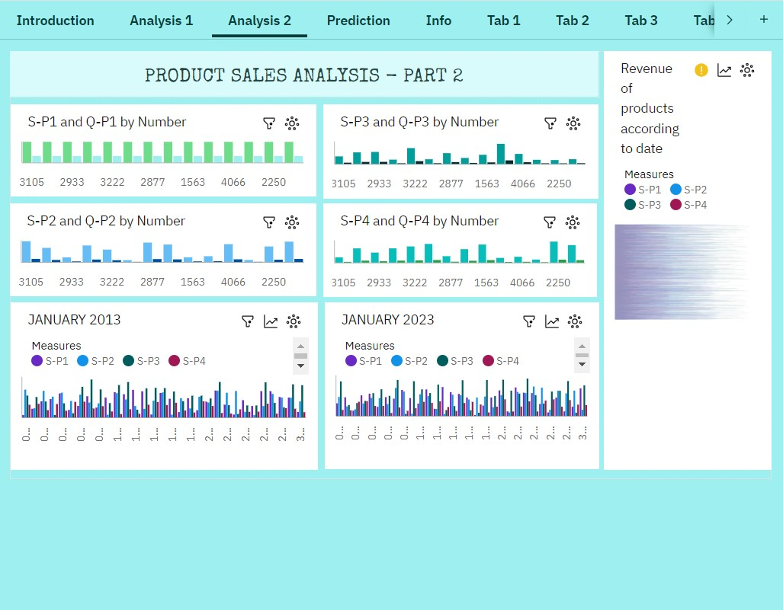

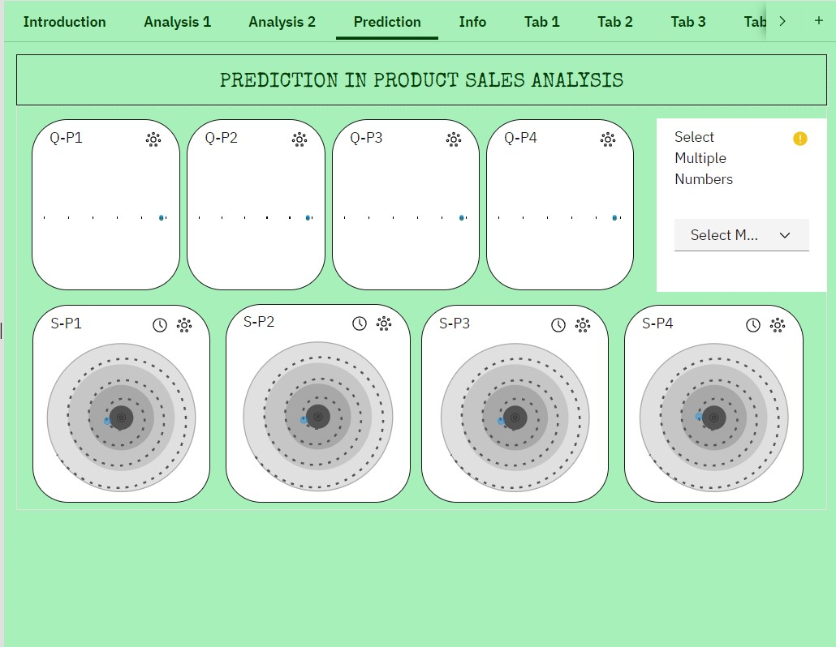

**CONCLUSION:**

It is clear that according to predictive analysis the **future sales of products will be higher and customer preferences over the products sold by REC Corp Ltd will also be higher.**